Controlling Home Appliances Through Brain
NAME: S.Pavan kumar
BRANCH:ECE (SKUCET)
Summary : The idea is to control home appliances like lights, fans through brain by using neural waves.Here we use a neural transmitter to transmit brain waves to the controller which is connected to the home appliances.
INTRODUCTON :
Brain is the most powerful thing we can ever see in the universe.It is the cause that we are placed in higher positions than other organisms o earth.We can do anything if we can control it.This Is just the basic idea of power of brain which paves way for wonderful inventions in future.
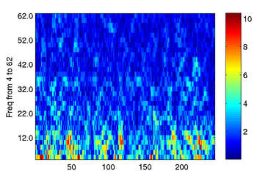

These are generally the brain waves look like.These waves are of a frequency of 50Hz.Hence they are not audible.We have to amplify these waves and convert them to EM waves using “Electroencephalogram” generally called EEG.
This is a test that measures and records electrical activity of brain.Special sensors called electrodes are attached to our brain.By using this technique we we can convert brain waves to EM waves.Then by using a transmitter we transmit these waves to a controller through a receiver which is used to convert the received EM signals to electrical signals.The controller is connected to the home appliances ,thus we can control the devices without any human effort.
The transmission part is given below.It’s not exactly the same but it represents the wave transmission.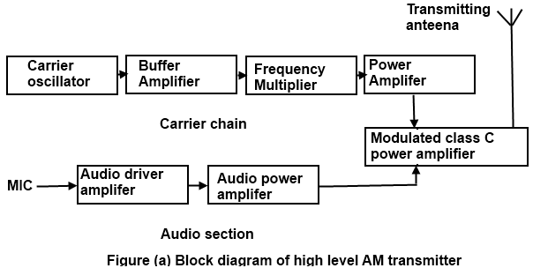
At the receiver this is again converted back to the electrical signal and applied to the controller.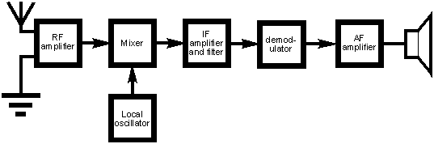

CONCLUSION:
By inventing devices like this we can make the efforts less and work in a more efficient way.This is just the basic model but in future ,if we continue like this we can use the unexplored parts of the brain and can do wonders.Coming to this design it is more useful to the paralysed people.They can do their works easily with the use of this device.

